Renju lesson on October 5, 2000

Hello!
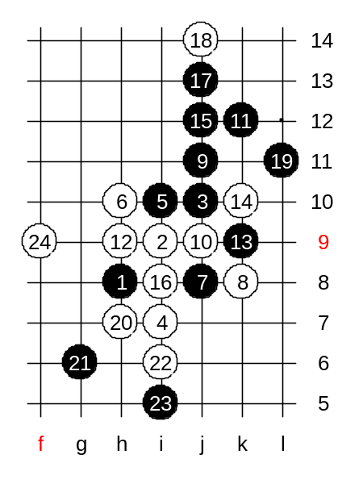
We will continue studying the i1 opening. today's topic is another 5th move - 5-i10. The 6th move is quite obvious. I think the players regardless of their level can find the correct 6th move. Yes, h10 it is. The same thing about 7th move - its very natural, obvious, and easy to find. Japanese traditional theory tells about 8-k8. I guess it was often played in old times. That 8th move is quite interesting, it blocks black's horizontal pair as well as one important diagonal line. Such defense is very powerful in many opening patterns. Now, black uses the attacking style which does not necessarily work in other situations, but is perfect for this case. 9-j11 - black's tactics is to stretch out towards upper side space and develop there. Lets look at the example where white plays simply 10-j9. Well, if until this moment all the moves were pretty obvious, then next moves may be a little bit tricky. Black has to think of how to develop towards space and at the same time keep the white structures under control.
Lets see, if you can guess the next move. Move k12 seems to be very good in the meaning of space development. We only have to make sure that white cannot do any harm. It seems, white cannot do anything after black's k12. So, those who guessed k12 are right. Obviously, white has to try to block actively. By the 13th move the situation is becoming clear - although it's white's turn to move, it doesn’t help much because black space development is too powerful. So, no matter how white plays, black wins in few moves. The best white move in this situation is 14-k10. Do you know why? First of all, it blocks several black lines. besides that, it will not black develop "softly" anymore. Because thanks to the stone at k14, white can make a VCF threat at i8 in case of any "soft" black move. Therefore, after such 14th move, black must use straight attack. Well, if this is not so clear, lets play it here to make it visible. Lets say, black would choose wrong way to develop, a "soft" development. Lets try 15-j12. White can win now with 16-i8.

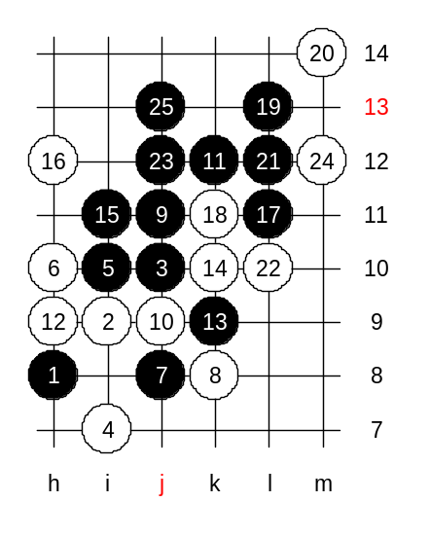
In conclusion, black has to use straight attack. Now, I am waiting your suggestions for black's straight attack. I also give you one hint. Obviously, black has to use the diagonal three to begin straight attack since there are no other available material. h12 or i11? One is right and gives win, one is wrong and gives black loss in long term. Those who guessed i11 are right! My analysis also proves black win after i11. Lu suggestion for black's next move is L11 - also correct. After that, white is helpless. Indeed, white can block black's three from the left side with a four, but it does not help much, because black will still have VCF threat.

Do you know a legendary old Japanese player Yoshizawa? 20 years ago, there was a match between Yoshizawa and Nakamura. He was around 60 years old at that time.
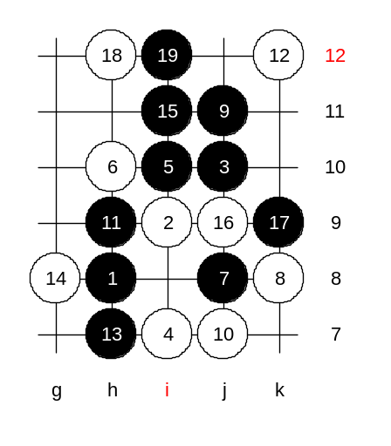
The match of 7 games ended with Yoshizawa win 4:3. Then the old man just disappear so suddenly as he had appeared. I asked Nakamura about him last year. He said he does not know what Yoshizawa is doing now or if he is alive or not. Yoshizawa had a wonderful fighting spirit. All his games were full of ideas and active moves. In this variant, the 10th move, j7, was his analysis. It looked unbelievable for me too in the first look. How can white play actively on the lower side while black has so much material? The answer is: Black can only combine his material by attacking towards upper side. But if black plays moves to k12 and j12, then white will have a three at h9, j9. Therefore, despite the black's big advantage in upper side, white has forced black change the tactics with that beautiful j7 move. Lets use logic: If black cannot attack, then looking at white structure, we see that black cannot just develop softly in upper side while white has all the activity below. Therefore, black has to take care of white structures first. Black has to defend actively in order to keep the initiative. The optimal solution is h9 and h7. The situation after 14 moves: Black has "sacrificed" part of the attacking material for defense purposes. But in return, black has achieved the situation where white activity is dead and therefore black can continue developing softly in upper side. Move 15-i11 is the best. I analysed this position before and I did not find any good moves for white. It seems that 16-j9 is the best. However, black can set the winning position in two moves: 17-k9 (eliminates white possible counter-attack) and 19-i12 (prepares the final base for winning attack.
Can you please suggest me the best white defense, so that we can test it here and see that black can still win. We will do this way, I give some homework based on this position.
We will have two homework questions. The medium level homework is to find black win after 20-k11. The advanced level homework is to find black win after 20-L9 (please include all sub-variants).
Please use RenLib to send me the answers. That way it is easy for you to record the answer and easy for me to check your answer. I will quickly show you one more diagram now and then we are done with this 4th move.

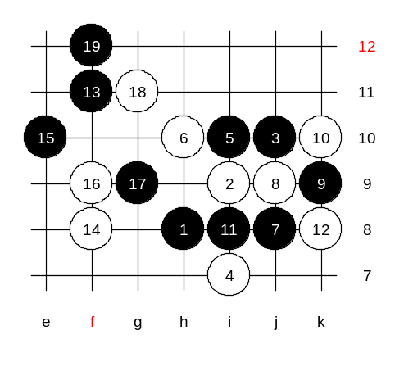
We change the 8th move. In my opinion 8-j9 is the strongest move. Black can get the advantage only through careful positional development. Lets see how it goes. By the 12th move the position is quite similar to the variant that comes from 4-h11. Remember, I taught you this before. The only difference is the white stone in h10 instead of h11. Here, the white stone stands on better position, and black cannot win straight. Black will use a series of space moves instead.
13-f11! 14-f8. 15-e10!!
Black can play into space and does not need to worry about white line because it is controlled from i11 point. Best white move here is 16-f9. After 19-f12 black has achieved total control over space and structures. Yes, it is hard, but it is the only way here, unfortunately. It takes time until you will learn to figure out such moves, until then you will just have to remember and learn. After 19th move, black development is quite easy and most of you can do it quite well. I announce the lesson to be finished for today. Thank you for coming.

